Computer Language Coding Concepts

Pointer Assignments
Pointer assignments establish a pointer to pointer. Instead of assigning a target object to the reference, you assign a reference to the reference. This creates a pointer-to-pointer, instead of a direct reference to an object. This allows another object reference to decide which object is eventually targeted.

A pointer assignment always has a reference as a source, not its object, not its class, but the reference itself.

A pointer assignment is displayed with an arrow inside the diamond.

Object Pointer Assignment:
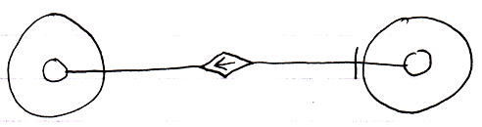
Reference Get ←
Object Set → (~= Other Related Item Set)
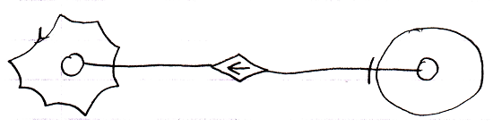
Reference Get ←
Object Set → (~= Other Related List Item Set)

Reference Get ←
Object Set → (~= Other Related List Item Set)

Because Object Set has overloaded implementations to also support taking a Related Items and Related List Items, it is still the Object Set command that is called, but it redirects to the reference Set commands.

Pointer assignment also works for class assignments. You can use a reference as a class, instead using an object itself as the class:

Class Pointer Assignment:
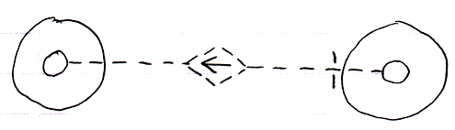
Reference Use As Class ← (~= Reference Get)
Class Set → (~= Other Related Item Class Set)
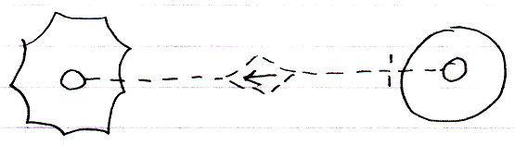
Reference Use As Class ← (~= Reference Get)
Class Set → (~= Other Related Item Class Set)
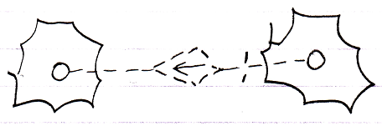
Reference Use As Class ← (~= Reference Get)
Class Set → (~= Other Related List Item Class Set)

See also: System Objects, Assignment

Author & Copyright: Jan-Joost van Zon Date: July 27, 2009 – August 6, 2009 Location: Oosterhout, The Netherlands Status: Finished

